**Practical No. 2**

**Write a PHP program to demonstrate the use of Decision making control structures using-**

**a. If statement**

**b. If-else statement**

**c. Switch statement**

**Code (Pg no. 84):**

<?php

$n1=10;

$n2=5;

$n3=2;

$ans= $n1+$n2*$n3;

echo "$n1+$n2*$n3=$ans<br/>";

$ans=($n1+$n2)*$n3;

echo "($n1+$n2)*$n3=$ans<br/>";

?>

**Output:**

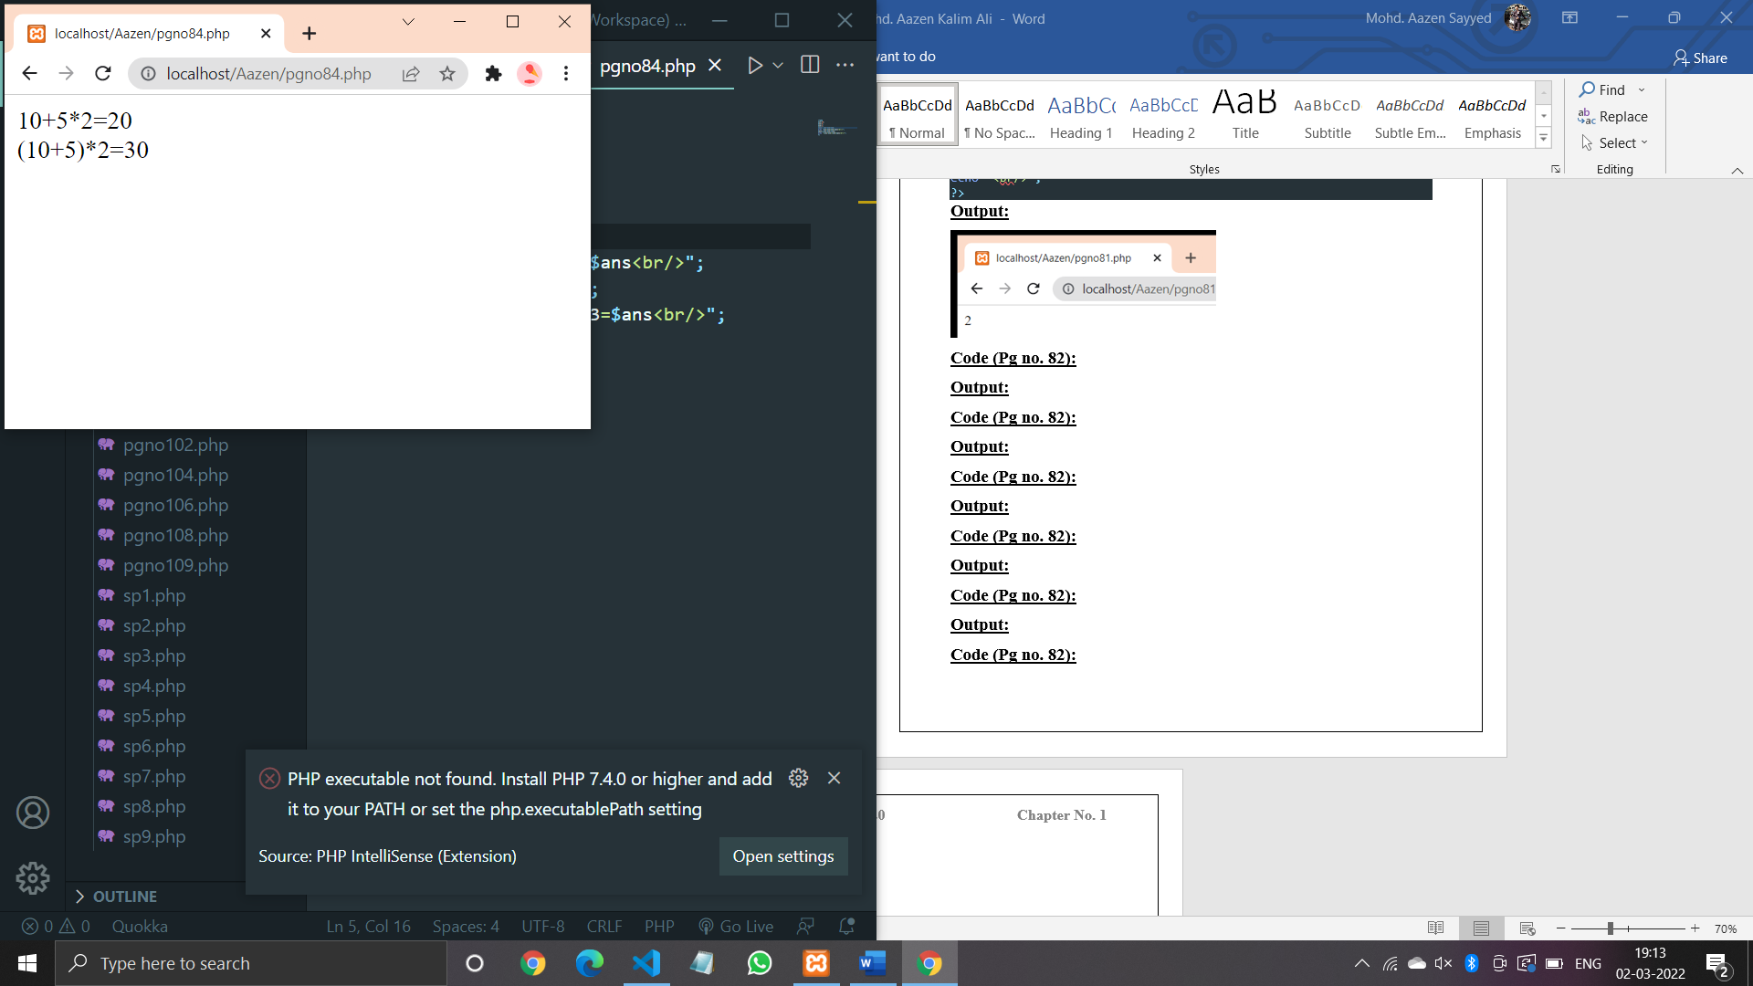

**Code (Pg no. 86):**

<?php

define("HELLO","Hello PHP");

echo HELLO,"<br/>";

define("HELLO","Hello PHP");

echo hello;

?>

**Output:**

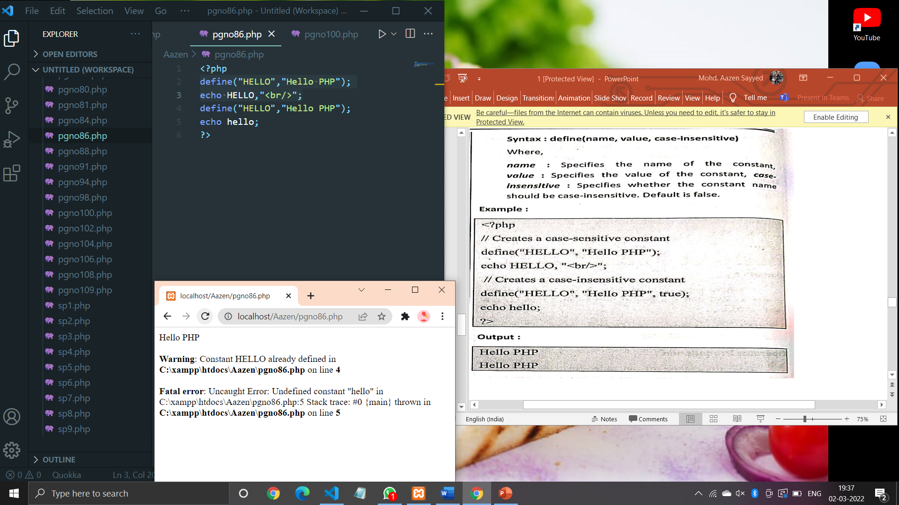

**Code (Pg no. 88):**

<?php

$a=10;

*if*($a>0)

{

    echo "The number is positive";

}

?>

**Output:**

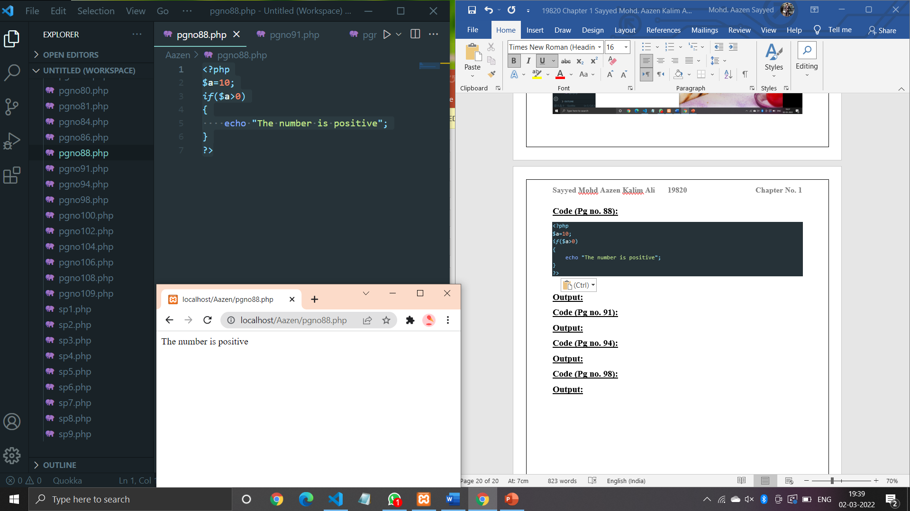

**Code (Pg no. 91):**

<?php

$a=-10;

*if*($a>0)

{

    echo "The number is positive";

}

*else*

{

    echo "The number is negative";

}

?>

**Output:**

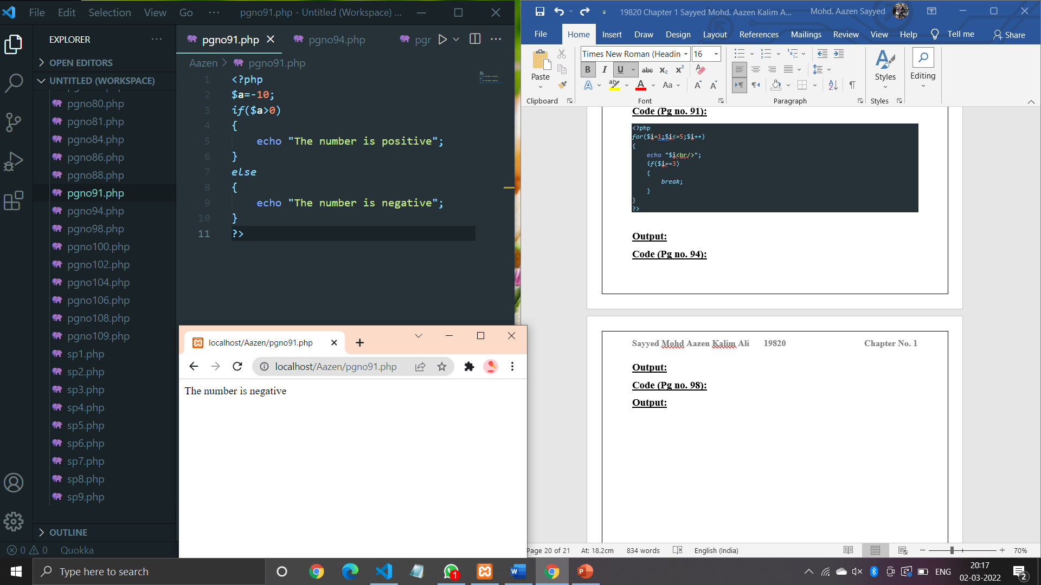

**Code (Pg no. 94):**

<?php

$per=65;

*if*($per>=75)

{

    echo "Distinction";

}

*else* *if*($per<75 && $per>=60)

{

    echo "First Class";

}

*else* *if*($per<60 && $per>=45)

{

    echo "Second Class";

}

*else* *if*($per<45 && $per>=40)

{

    echo "Pass Class";

}

*else*{

    echo "Sorry Fail";

}

?>

**Output:**

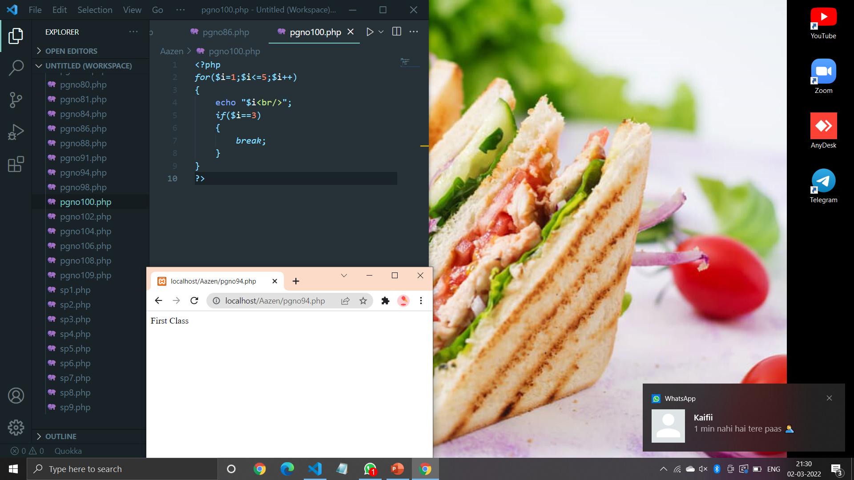

**Code (Pg no. 98):**

<?php

$ch=1;

$a=20;

$b=10;

*switch*($ch)

{

*case* 1:

        $c=$a+$b;

        echo "Addition =".$c;

*break*;

*case* 2:

        $c=$a-$b;

        echo "Subtraction =".$c;

*break*;

*case* 3:

        $c=$a*$b;

        echo "Multiplication =".$c;

*break*;

*case* 4:

        $c=$a/$b;

        echo "Division =".$c;

*break*;

*default*:

        echo "Wrong Choice";

}

?>

**Output:**

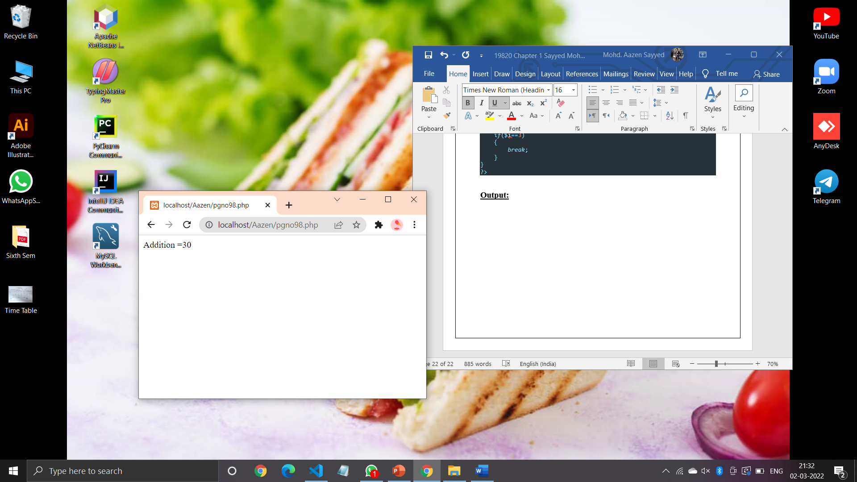

**Code (Pg no. 100):**

<?php

*for*($i=1;$i<=5;$i++)

{

    echo "$i<br/>";

*if*($i==3)

    {

*break*;

    }

}

?>

**Output:**

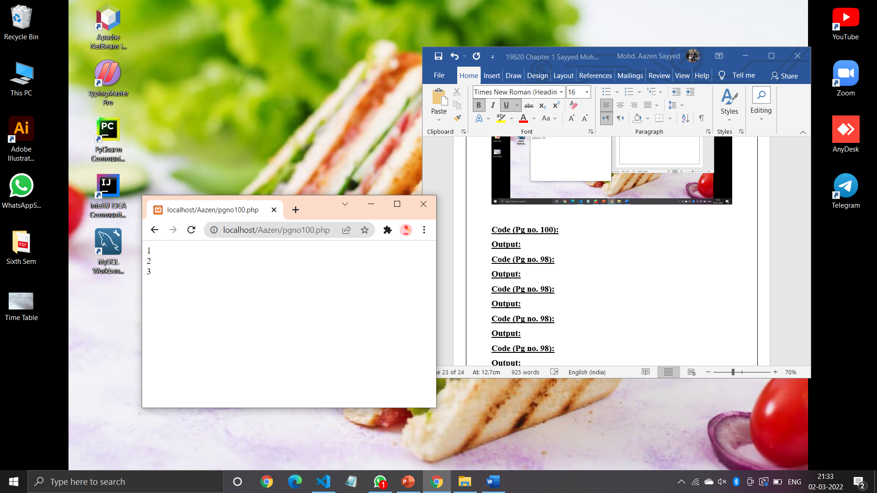

**Code (Pg no. 102):**

<?php

*for*($i=1;$i<=5;$i++)

{

    echo "$i<br/>";

*if*($i==3)

    {

*continue*;

    }

    echo "$i<br/>";

}

?>

**Output:**

